**CHEMISTRY CLASS 12 ANSWERS**

**Part 1 Answers**

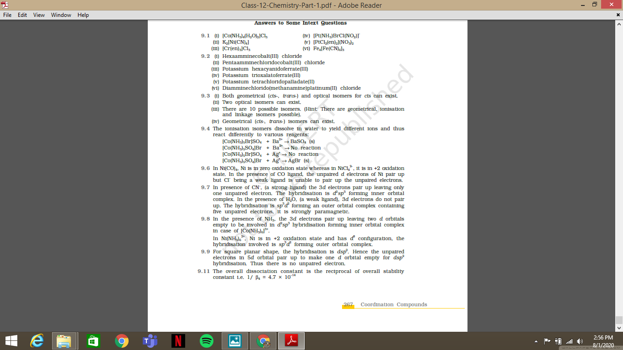

Part 2 Answers

